**CO329 Assessment 4 – Project**

**Project Introduction:**

The British Heart Foundation released statistical data on different cardiovascular death rate during 1969-2016. In this project report, I will be investigating and analysing data answering the 4 task questions with graphs, statistical tests; with research to better express my views.

# **Task 1:**

The general lowest mortality causes were Diabetes (E10-E14) with 6,768 death cases being 1.13% of the total deaths in 2016. But results vary per age group, as Dementia and Alzheimer’s having zero to fewer deaths for both genders until age 55+ in which double against Diabetes.

Diabetes is a metabolic disease as the body cannot create insulin effectively making it common with older adults. Diagram 1 below shows death data for both males and females age 35+. A study performed by The Scottish Diabetes Research Network Epidemiology Group explicates that the BMI of male patients kept being higher of close to females which can lead to low insulin and type 2 Diabetes. From age 85+ female death number grew more than males as different factors e.g. age, impact overall the number of diagnosed cases. (1)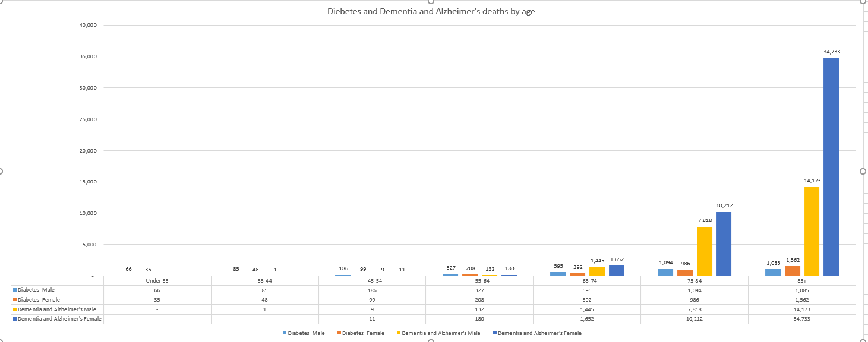

Diagram 1

# **Task 2:**

The provided data presents a decrease in numbers of CVD death cases between the years 1969-2016. By analysing the ‘Years’ tab of the Excel spreadsheet; It’s clear that in the 20th century both genders had high case numbers, but woman cases kept lowering drastically compared to men during the study. Certain factors e.g. genetics and lifestyle choices show that woman lifespan usually longer than men even with the same CVD diseases. (2)

According to the British Heart Foundation, it was noticed that woman death cases decreased by nearly 75% as factors e.g. science improves aiding health services better handle CVD cases. Diagram 2 presents a weak negative correlation as the cases fluctuate between years, the regression life shows the relationship between the death rate and years.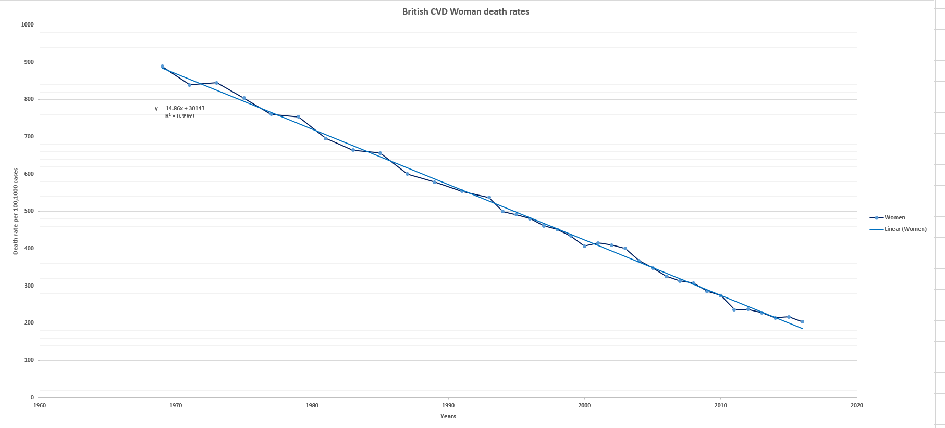

Diagram 2

# **Task 3**

The Scottish CVD death rate decreases through the years as scientific research is improved aiding health services to handle CVD cases. By analysing the ‘Years’ tab of the Excel spreadsheet; I investigated if this data could be modelled using a linear regression technique.

Linear regression is a common modelling technique, it establishes a relationship between the Y variable (dependent) and one or mode X variable (independent) using the regression line. By using Y=a+b*X + e, I was able to use the intercept, the line slope and the error term to calculate the regression line. I used a line to join the points and the best fit line as it's useful representing the equation data, which is shown below the graph plot. (3)

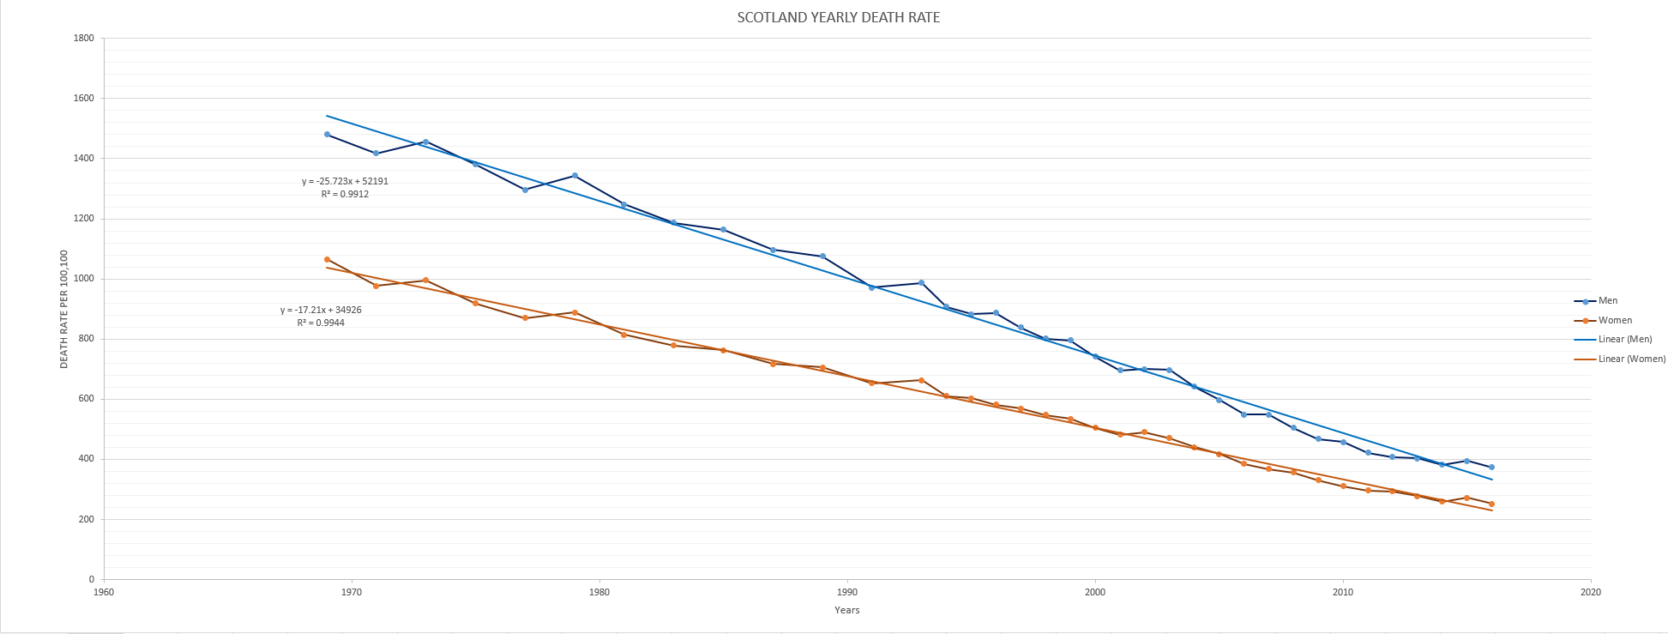

Diagram

# **Task 4**

The Welsh CVD death cases also followed the UK pattern of case decreasing over time in a negative correlation. I analysed the “Years” tab of the Excel spreadsheet in my research and will be comparing UK and Wales results for consistency with the aid of a graph.

With the given data, I made a line graph (Diagram 4) to better show the table result content. Across the study period, Wales kept having higher cardiovascular disease death cases compared to UK results, which is alarming due to its smaller population as CVD being the highest killing disease in the UK.

Genders also impacted the collected data. Male cases were narrow in 1995 and 2003 but never intercepted the UK, compared to Woman which narrow in 1987, 1991 and 2011. As factors e.g. genetics aided Woman of both sets (Wales and UK) keeping having fewer deaths than Men. 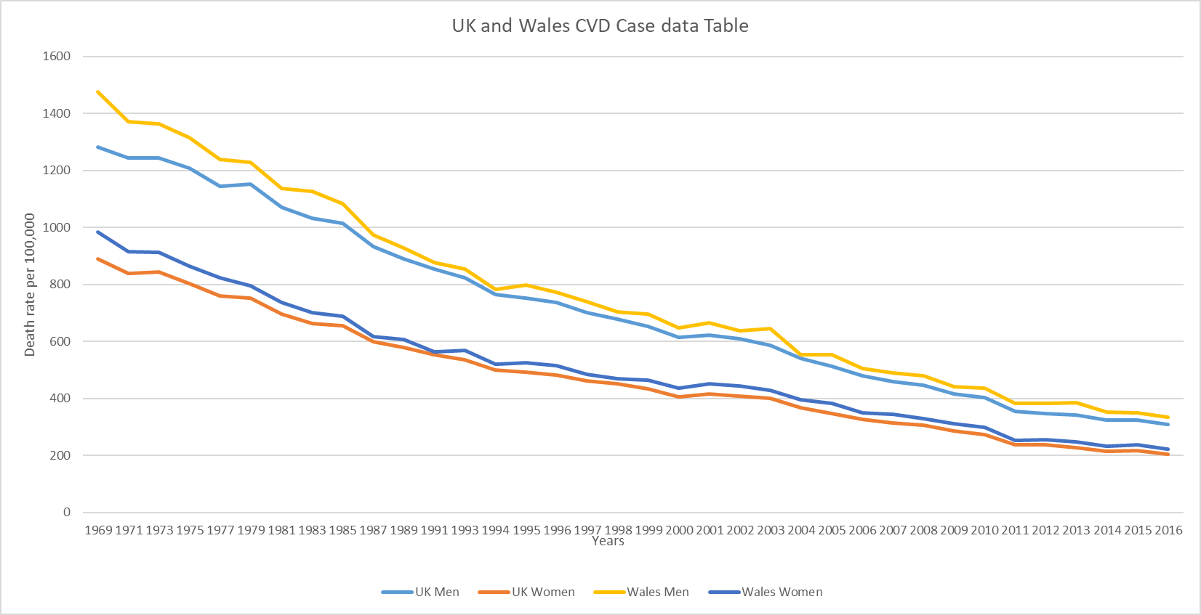

Diagram

**Conclusion**

In this report, I investigated the Excel spreadsheet containing data of death cases in the UK. By having extensive data sets, I was able to analyse it with stricter accuracy aiding my investigation

I discussed in Task 1, how data sets can be compared giving a clear view of the issue e.g. death causes. In Task 2, I discussed how correlations results and outside sources help support my opinions with the presented data. In Task 3, I discussed how statistical techniques can be used to better explain data sets, I explained the technique and how was useful was calculating the regression line. In Task 4, I compared the UK and Wales data with a graph, providing critical points and reasons for my argument

**Appendices**

1. Diagram 2: =CORREL (Men, Woman) = 0.998344143
2. Diagram 3: = CORREL (MEN, Woman) = 0.997378061

**References**

(1): Louge, J. & Walker, J, Colhoun, H & Leese, G & Lindsay, R & Mcknight, J & Morris, AD & Pearson, D & Petrie, J & Phillip, S & Wild, S & Sattar, N (2011). On Behalf of The Scottish Diabetes Research Network Epidemiology Group. Do Men Develop Type 2 Diabetes at Lower Body Mass Indices Than Women? [online] Available at: <<https://www.researchgate.net/publication/51682145_on_behalf_of_The_Scottish_Diabetes_Research_Network_Epidemiology_Group_Do_men_develop_type_2_diabetes_at_lower_body_mass_indices_than_women>>[Accessed 21 March 2020].

(2): Scarborough P, Wickramasinghe K, Bhatnagar P, Rayner M (2011). Trends in coronary heart disease 1961-2011. British Heart Foundation: London. [Accessed 22 March 2020].

(3): Barron, A., 1997. Linear Regression. [online] Stat.yale.edu. Available at: <http://www.stat.yale.edu/Courses/1997-98/101/linreg.htm> [Accessed 23 March 2020].